Project-Specific Professional Liability Indication Worksheet
Please fill out the following form in its entirety and return to the Americas Legal team with an attachment of the applicable contractual insurance requirements.
- Date: | November 16, 2023
- Coverage: | Professional Liability (PL) Only? |  |  | Y | PL and Contractors Pollution Liability? |  | N
- Joint Venture Contracting Entity: | Unincorporated joint venture consisting of: Arup US, Inc., Atkins North America, Inc., and The McKissack Group Inc.
- Project Description: | The Hudson Tunnel Project has Three Major Components  New, Two-Track Hudson River Tunnel: A new, two-track Hudson River rail tunnel will be constructed between the Bergen Palisades in New Jersey to Manhattan.  Hudson Yards Concrete Casing, Section 3: A third and final rail right-of-way preservation section will be built underneath Hudson Yards in New York. This will eventually allow trains to travel between the new Hudson River Tunnel and the existing Penn Station New York.  North River Tunnel Rehabilitation: The existing tunnel beneath the Hudson River, which has suboptimal service reliability its and antiquated design, and was severely damaged during Superstorm Sandy, will be rehabilitated.  These three components will improve reliability, resiliency, and redundancy for hundreds of thousands of daily passengers who travel across the Hudson River, and allow for much-needed repairs on an essential stretch of the Northeast Corridor. Upon completion of the Hudson Tunnel Project, four tracks (two in the new Hudson River Tunnel and two in the North River Tunnel) will be available between New Jersey and New York under the Hudson River, which allow for operational flexibility and redundancy for Amtrak and NJ TRANSIT rail operations to maintain current capacity levels.
- Joint Venture’s Scope of Services: | The Gateway Development Commission (“GDC”), through the National Railroad  Passenger Corporation (“Amtrak”), is soliciting proposals for “Delivery Partner” (DP)  services to support development and execution of the Hudson Tunnel Project (HTP). The Delivery Partner will serve as staff extension to GDC and increase GDC’s technical, financial, and legal capacities to manage and deliver the Hudson Tunnel Project including enhancements to project planning, programming, design management, and construction management capabilities.
- What is the scope of any subs or other firms to be insured? | All subconsultants will perform services consistent with the range of Delivery Partner services noted above, namely “staff extension to GDC and increase GDC’s technical, financial, and legal capacities to manage and deliver the Hudson Tunnel Project including enhancements to project planning, programming, design management, and construction management capabilities.”
- Project Owner: | Gateway Development Commission (GDC) through the National Railroad Passenger Corporation (Amtrak)
- Contractor: | Multi-Contract program: Package 4 below is awarded to Conti Civil LLC. Package 0 below will be developed by Related Companies.  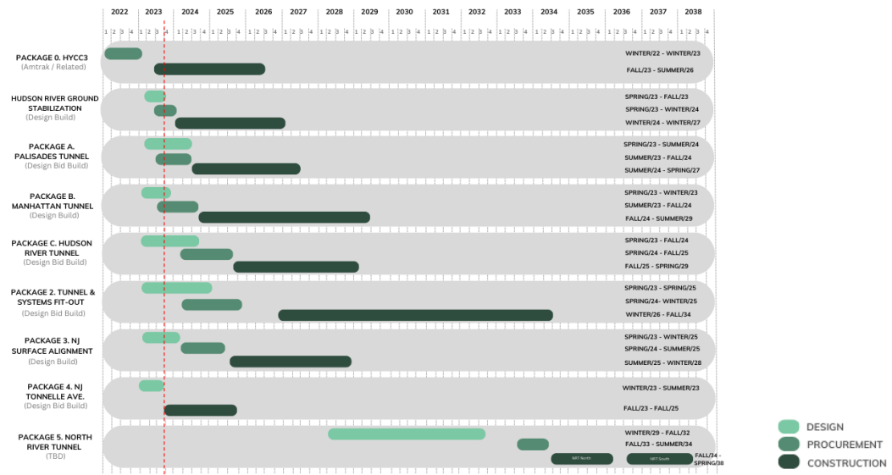
- Project location: | New York and New Jersey
- Project Schedule: | Start of Design DP Services |  | Start of Construction |  |  | End of Construction
 | March 1, 2024 |  | March 1, 2024 |  |  | Spring, 2038
- Fees for firms to be insured on the policy and construction values: | Fee for Joint Venture (excluding subs and T&E reimbursables) |  | Fee(s) for all other firms to be insured on the policy |  |  | Construction Value(s)
 | ~$450M |  | ~$175M |  |  | ~$16.1B
- Quote options: | Policy Limit |  | Deductible (per-claim) |  |  | Extended Reporting Period (# years)
Option 1: | $10,000,000 |  | $500,000 |  |  | 10 years
Option 2: | $15,000,000 |  | $500,000 |  |  | 10 years
Option 3: | $20,000,000 |  | $500,000 |  |  | 10 years
Option 4: | $25,000,000 |  | $500,000 |  |  | 10 years
- In addition to the joint venture, list the names or description of all other firms to be covered. If any firms listed are not subs to your firm, such as an owner’s consultant, please explain. |  | TBC.
- If Construction Management services are to be performed, are they At-Risk or Agency? |  | CM services are Agency.
- What is the project delivery method (design-bid-build, design-build, P3, etc.)? |  | The type of project delivery per contract is noted above, mostly Design-Bid-Build, with some Design-Build.
- Is this a Guaranteed Maximum Price or Lump Sum contract? |  | No. It is cost plus fixed fee to a cap, negotiated on a task specific basis.
17. Are any of the firms to be covered contractually responsible for the work of contractors?  (i.e. will any of the firms to be covered enter into sub-contracts with contractors to provide construction services?) |  | No.

Please attach the corresponding insurance requirements per the RFP.

Arup contact:
Name of Legal Team Member: Natalie Bloch
Arup Office Address: 77 Water Street, Floor 5, New York, NY 10005
Phone: 212-896-3159
Email: natalie.bloch@arup.com

Insurance Broker contact:
Gregg Bundschuh
Greyling Insurance Brokerage, a division of EPIC
3780 Mansell Rd, Suite 370
Alpharetta, GA 30022
P: 770-552-4225
gregg.bundschuh@greyling.com

